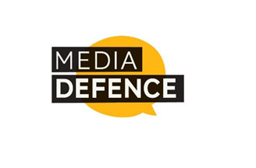
Application Form
Peer Support Programme

One-to-One Peer Support, October 2022 to October 2023

This is the application form for the Media Defence Peer Support Programme for Women Lawyers in sub-Saharan Africa. It comprises three sections all of which need to be completed. The boxes can be expanded to fit your responses.

Please e-mail your completed application form by 30 September 2022 to hanna.uihlein@mediadefence.org.

Shortlisted applicants will be notified soon after the closing date.

SECTION 1: APPLICANT DETAILS
Given name(s): | Surname:
Gender: | Age:
Organisation:

Address:

Country of residence:

Mobile / WhatsApp number: | Office / other contact number:
Email address:

SECTION 2: EXPERIENCE:
In this section, respond to the following questions with relevant experience, giving examples where possible.
- What is your legal background and experience (e.g. relevant qualifications, area of practice, and general litigation experience)?

- What experience best describes your interest in and/or knowledge of digital rights and the right to online freedom of expression? (feel free to provide more than one experience)

- What are your objectives for the peer support programme? (e.g. what do you want to learn, what experience do you like to share)

- Which topics are you interested in most? (professional growth, interpersonal skills, litigating, etc.)
- Please rate your current network of women lawyers. On a scale of 1-5 whereby: 1= I do not have a network of women lawyers, 3 = I am connected to some women lawyers, 5 = I have a strong and well connected network of women lawyers.
- What qualities are particularly important to you in your partner for the peer support programme?
- Any other relevant information or comments?

